CHOPARD

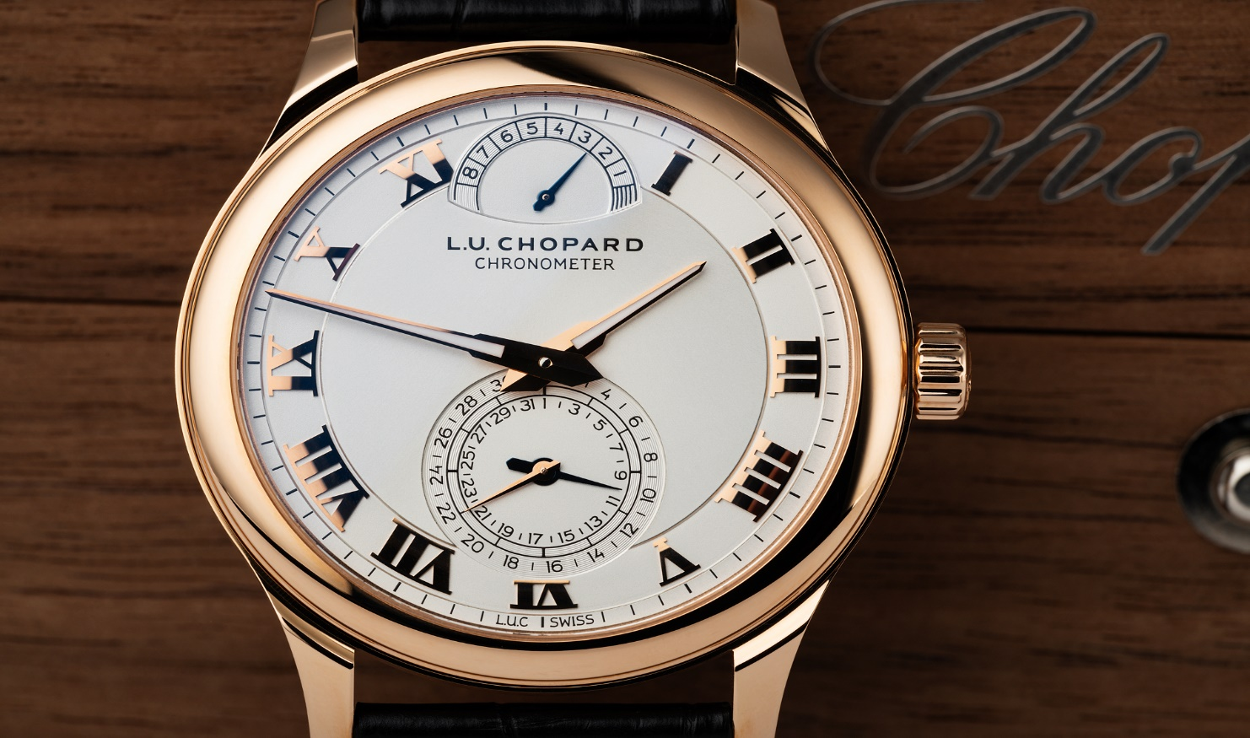DESCRIPTION: Chopard is a prestigious Swiss luxury brand known for its exquisite watches, fine jewelry, and dedication to craftsmanship. Founded in 1860 by Louis-Ulysse Chopard, the brand has built a reputation for precision timekeeping and elegant design.

Chopard is best known for its iconic watch collections, including the **Happy Sport**, featuring its signature floating diamonds, the **Mille Miglia**, inspired by classic racing aesthetics, and the **L.U.C** series, which showcases the brand’s expertise in haute horology. With a strong commitment to ethical sourcing, Chopard also leads in sustainable luxury, using fair-trade gold and responsibly sourced materials.

Combining Swiss precision with artistic elegance, Chopard watches represent luxury, sophistication, and timeless beauty, making them a favorite among collectors and connoisseurs worldwide